Water Services
SCADA Standards
TELEMETRY SYSTEMS

Contents
1 Purpose 6
1.1 Background 6
1.2 Note on terminology 6
2 Scope 7
2.1 Telemetry Systems Definition 7
3 Telemetry System Selection 8
4 Ethernet Radio Systems 9
4.1 Legacy Ethernet Radio Systems 9
4.2 Hardware 9
4.3 Configuration Software 9
4.4 Station Naming 10
4.5 File Storage 10
4.6 PLC Messaging 10
4.7 Configuration 10
4.7.1 Time Synchronisation 10
4.7.2 Operating Modes 10
4.7.3 Radio Settings 10
4.7.4 Serial Ports Settings 11
4.7.5 Ethernet Ports Settings 11
4.7.6 IP Settings 11
4.7.7 Security 11
4.8 SNMP 12
4.9 Remote Computer Connection Across Ethernet Radio Links 12
5 Miri RTU Systems 13
5.2 Legacy Miri RTU Networks 13
5.3 Hardware 13
5.4 Configuration Software 14
5.5 Configuration and Programming 14
5.5.1 File Storage 14
5.5.2 Station Numbering 14
5.5.3 Station Naming 14
5.5.4 Station Description 15
5.5.5 Variable Structure 15
5.5.6 Parcels 19
5.5.7 Remote Station to Remote Station Data Transfers 20
5.5.8 Control of Equipment 20
5.5.9 Ladder Logic 20
5.5.10 RSSI Calculation 21
5.5.11 Analogue Scaling 21
5.5.12 Housekeeping 21
5.5.13 Citect Modbus Salve Stations 21
5.6 Time Synchronisation 21
5.7 Communication Configuration 21
5.7.1 RTU to RTU 21
5.7.2 RTU to PLC 22
5.7.3 RTU to CitectSCADA 23
5.7.4 RTU to RTU Communications Watchdog 23
5.7.5 PLC to RTU Communications Watchdog 24
5.7.6 CitectSCADA to Modbus Slave RTU Watchdog 24
5.8 Store and Forward Stations 24
6 Small Scale RTU Systems 25
6.1 RTU Data Link Architecture 25
6.2 Communications 25
6.3 Limitations on RTU data into Citect 25
6.4 RTU Hardware Selection 25
6.5 Software Version 26
6.6 ClearSCADA Configuration 26
6.7 Naming 26
6.8 RTU Configuration 26
6.8.1 DNP3 26
6.8.2 Comms 26
6.8.3 APN Settings 27
6.8.4 I/O 27
6.8.5 Groups 27
6.8.6 Points 27
6.9 Installations for Intermittent Monitoring 29
6.10 Installations for Continuous Monitoring 29
6.11 File Storage 29
7 Installation 30
7.1 Antenna Selection 30
7.2 Antenna Installation 30
7.3 Coaxial Cable 30
7.4 Cable Runs and Connectors 31
7.5 Cable Support 31
7.6 Cable Protection 31
7.7 Moisture Ingress 31
7.8 Surge Protection 32
7.9 Coaxial Earthing 32
7.10 RF Filters 32
7.11 Power Supplies 32
7.12 Installations in Communications Cabinets 32
8 Change Management 33
8.1 Version Control 33
9 Documentation 33
10 References 34
10.1 Legislation and Regulatory Obligations 34
10.2 PWC Water Service SCADA Standards 34
11 Definitions 35
12 Roles and Responsibilities 37
12.1 Document Owner 37
12.2 SCADA personnel 37
12.3 Contractors 37
13 Records 37
14 Review 37
15 Document History 38

Figures
Figure 1 - Miri data transfer layout 16
Figure 2 – Eternet/IP Controller Tag Structure 17
Figure 3 – Variable Mapping with Ethernet IP Integration 18
Figure 4 – Variable Mapping with Ethernet IP Integration 18
Figure 5 – Remote Station to Remote Station Data Transfers 20
Figure 6 – Metasphere Point Orange Point Details configuration example 28
Figure 7 – Metasphere Point Orange Event Generation configuration example 28

Tables

Table 1 – 4RF radio Layer 2 filtering 11
Table 2 – Station numbering standard 14
Table 3 – Remote station data structure 17
Table 4 – Base Stations and Citect Modbus Slave Stations data structure 19
Table 5 – Coaxial Cable Selection 31
Table 6 - Referenced Standards 34
Table 7– Definitions 36
Table 8 – Document History 38

Purpose
The purpose of the document is to provide standards for Telemetry Systems hardware and software across the Client SCADA System.
The SCADA Standards are intended to be used across both development and maintenance processes.
This document forms a part of the Client SCADA Standards package.

Background
We have identified SCADA Systems standardisation, across the Services group, as a key requirement for projects, operations and maintenance. Standardised systems provide a link to the corporation’s strategies and improve efficiency and reliability across all facilities with SCADA functions.
In 2022 a capital project was executed to create SCADA Standards documentation to provide a platform for delivery of major projects and upgrades of existing sites. Additionally, the standards would provide procedures and guidelines to maintain Services SCADA Systems.

Note on terminology
Services have historically used the term ‘SCADA’ to describe all aspects of the control systems supporting operations. This includes local logic controllers (PLCs), RTUs, telemetry, operator HMI control panels and centralised graphical user/operator interfaces (what is commonly referred to by itself as a SCADA system). This document shall continue to use the term SCADA as referred to by CLIENT.

Scope
This standard applies to all Services SCADA RTUs and associated radio and communications links (referred to as telemetry systems), and any works performed on these systems by SCADA personnel or external contractors.
Physical layer systems not owned and by the Services SCADA group do not fall under this standard. For example, third party telco provided networks.
Exceptions to this standard due to functionality with existing systems, or any other factors, shall require written approval from SCADA personnel.

Telemetry Systems Definition
In the context of the Services SCADA System, telemetry comprises narrowband data links between sites and the communications devices in the field at those sites. This includes what are commonly known as Remote Telemetry Units (RTU’s) and associated radio links, as well as Ethernet Radio systems and communications over links provided by third parties (telco cellular, satellite, landline). PLCs connected by telemetry systems are considered outside of the scope of telemetry.

Telemetry System Selection
The selection of a telemetry system will be dependent on type of application. Any selection shall be defined by the plant functional specification and require approval by SCADA personnel.
New networks of telemetry devices shall be supported by detailed design documentation (new networks being telemetry system implementations that are not just an addition to an existing network). Existing telemetry systems may also dictate what new equipment is required.
Ethernet radio system design and upgrade shall consider quality of service in relation to the volume of IP traffic and the impact on existing network architecture.
The IP Networks and Communications Installations SCADA Standard Section describes design considerations for telemetry systems.

Ethernet Radio Systems
CLIENT has standardised to the 4RF Aprisa SR+ platform for Ethernet radio systems. They may be used in point-to-point or point-to-multipoint configurations. They are used primarily as an Ethernet transmission system and are not used for data aggregation or collection.
The following terminology shall apply to Ethernet radio systems:
- Base Station (point-to-multipoint configurations) – the base terminal as defined by the configuration of the radio network. The base station controls remote station access to the RF transmission medium.
- Remote Station (point-to-multipoint configurations) – a remote terminal as defined by the configuration of the radio network.
- Remote Station (point-to-point configurations) – the radio connected to the outer end of the link in relation to the SCADA WAN or plant LAN.
- PLC – PLCs or other data logger devices that utilise the Ethernet radio transmission medium.
The preferred network topology for point-to-multipoint configurations shall be for a PLC connected to the Base Station to aggregate data from the remote station PLCs and provide data to CitectSCADA. It is preferred that Citect not connect to remote station devices directly due to bandwidth restrictions. Where necessary, and with CLIENT approval, Citect may connect directly to remote station devices in a point-to-multipoint configuration but design of such systems shall take into account the available bandwidth for particular Citect drivers to operate on.

Legacy Ethernet Radio Systems
Services operates a small number of legacy Ethernet radio systems which include Trio and Viper platforms. Where changes or upgrades are being applied to parts of an existing Ethernet radio network it may be more practical to follow establish standards within that network, rather than follow standards in this document. Such changes will be approved in writing by SCADA personnel on a case by case basis.

Hardware
Ethernet radio hardware will be selected as per the Approved Hardware and Software SCADA Standard.
This provides standard 4RF Aprisa SR+ features including:
- 10-30V DC power supply
- Rugged and established platform
- 400-470MHZ licensed spectrum
- User friendly configuration via web browser

Configuration Software
Configuration of the 4RF Aprisa SR+ platform is via web browser or standard command line interface tools.

Station Naming
Each radio shall have a unique tag as per the convention in the IP Networks and Communications Installations SCADA Standard.
The location of the radio shall include the name of the CLIENT facility in which it is installed.
Contact details shall be ‘WS SCADA’.

File Storage
The configuration of each radio shall be saved in the Services software repository. The IP address shall be left out of the configuration file (when saving file ‘Retain IP Adress’ to be left unchecked).
The file name shall be in the format:
<Radio Tag>_<yyyymmdd>

PLC Messaging
PLCs communicating across the Ethernet radio network shall use the standard messaging logic as issued by CLIENT, using CIP Data Table Read/Write instructions. Produce and Consume tag methodologies shall not be used due to bandwidth restrictions. Refer to the PLC Systems SCADA Standard.

Configuration
The following settings are common across all 4RF Aprisa SR+ radios. Other settings are available and can be adjusted as required to achieve optimal performance of the Ethernet radio system. All radio configurations shall be reviewed by CLIENT prior to putting the system into operation.

Time Synchronisation
The radio internal clock shall be synchronised to the Services SCADA GPS time server via SNTP, where and a direct IP network connection is available, with an auto synchronisation period of 24hrs (86400 seconds). It should be noted that 4RF Ethernet radios can only display UTC time.

Operating Modes
These settings shall determine what function the terminal has within the network depending on whether the network is a point-to-point or point-to-multipoint topology. The Ethernet Operating Mode shall always be ‘Bridge’.

Radio Settings
- Transmit/Receive frequencies and power – as per ACMA issued license
- Channel size – Preference for 25kHz but restricted to ACMA issued license
- Modulation - Adaptive

Serial Ports Settings
CLIENT does not utilise the Ethernet radio’s serial port. Any utilisation of the serial port shall require SCADA personnel approval.

Ethernet Ports Settings
- All ports shall be enabled with management and user access.
- Layer 2 whitelisting shall be implemented to block multicast messaging as follows:
Rule | Source  MAC Address | Destination  MAC Address | Protocol Type
Allow ARPS | FF:FF:FF:FF:FF:FF | FF:FF:FF:FF:FF:FF | ARP
Allow Unicasts from Any source | FF:FF:FF:FF:FF:FF | FE:FF:FF:FF:FF:FF | Any
Table 1 – 4RF radio Layer 2 filtering
- VLAN – VLAN implementation shall be identified by network design documentation

IP Settings
Static IP addresses shall be assigned as per the Services SCADA IP Address Register.
Layer 3 filtering may be applied on a case by case basis with approval from SCADA personnel. This practice will be accompanied by detailed network design documentation. Other methods of reducing overhead IP traffic such as physical segregation and segmentation Shall take precedence over Layer 3 filtering within the radio.
If Layer 3 filtering is applied it shall follow a white listing scheme applied to the Base station only, to prevent undated SCADA WAN traffic propagating into the radio network. Layer 3 filtering shall not be applied to remote stations, where plant LAN physical segregation should take place instead.

Security
The payload security scheme shall be set to AES Encryption +CCM Authentication 128-bit. They payload and key encryption key type shall be passphrase with key size AES-128. The passphrases shall be issued by CLIENT.
The following protocols shall be enabled. All other protocols shall be disabled.
- ICMP
- SNMP – all versions
- SSH
Radios shall have one ‘admin’ user with password issued by CLIENT.

SNMP
The Services SCADA network monitoring tools shall use SNMP to gather data from Ethernet radios in order to provide network status information to SCADA personnel.

Remote Computer Connection Across Ethernet Radio Links
Under ideal conditions it is possible to connect by computer to a device across a 4RF Etherent radio network, depending on what software is being operated. Before performing this in the field, consideration shall be given to whether there is sufficient bandwidth capacity to perform the task and what impacts this will have on other devices communicating across the same link.

Miri RTU Systems
Miri RTUs have been used extensively in the Services SCADA system for some time. The largest application of Miri RTUs is for connection of pump stations. Other applications such as connection of small monitoring sites can include some simple control functionality also.
The following standards, as applied to Miri RTU Systems, have deviated from the legacy Miri network configurations. This standard is intended to establish a more efficient and easy to follow network and data structure.
The following terminology shall apply to Miri RTU systems:
- Base Station – the RTU radio master that controls polling of remote stations. Typically the base station is also the Citect Modbus slave.
- Citect Modbus Slave – the station (Mobus slave) on the a Miri network that Citect (Modbus master) polls for data. This is typically the Base Station RTU.
- Remote Station – RTU slave radios that are polled by the base station (does not include the PLCs).
- PLC – PLCs, data loggers and other endpoint devices as identified on the Miri network
The preferred network topology shall be for the Base Station to perform Modbus over TCP data transfer to CitectSCADA. Utilisation of a Remote Station as a Citect Modbus Slave station shall require approval from SCADA personnel and shall be identified in the plant functional specification.
The number of remote stations on a network shall be limited to 20 in order to:
        - Reduced dependency on single master stations/single points of failure. The probability of failure master stations is high due to wet season lightning and other weather.
        - Maintain responsiveness of CitectSCADA control and feedback, as dictated by operational requirements.

Legacy Miri RTU Networks
Where changes or upgrades are being applied to parts of existing Miri networks it may be more practical to follow establish standards and structures within that network, rather than follow standards in this document. Such changes and upgrades will be approved in writing by SCADA personnel on a case by case basis.

Hardware
Miri hardware will be selected as per the Approved Hardware and Software SCADA Standard.
This provides standard Miri RTU features including:
- 10-30V DC power supply
- M-series analogue radio
- 395-470MHZ licensed spectrum
- Digital inputs
- Analog inputs
- Serial and Ethernet ports

Configuration Software
The proprietary Miri programming software is used to configure Miri RTU Systems. The software version used shall be as per the Approved Hardware and Software SCADA Standard.

Configuration and Programming

File Storage
MiriMap configuration files shall be stored in the designated CLIENT software repository.
The file name shall be in the format:
<Base station site/facility>_Miri Network_V<NNN>_<yyyymmdd>
Where:
- Base station site/facility can be descriptive and include the asset number if applicable
- NNN is the software version number

Station Numbering
Each Miri RTU station has a unique identifier associated to it as per Table 2.
Station ID | Station Function
100 | Base Station
99 | Citect Modbus Slave (if not the Base Station)
1-20 | Remote Station
As per asset number | PLC, datalogger or other
Table 2 – Station numbering standard

Station Naming
Each station shall have a unique Station Name that shows the location of the station, site identifier and function. The base station and Citect Modbus slave shall also be identified where applicable.
The naming standard is as follows:
RTU#<Station ID> <Site ID> <Site name>
If the station is a Base Station or Citect Modbus slave then <Base station/Citect Modbus Slave> shall be added to the end of the name. If a station is not associated with a Site Identifier then this can be left out.
For example:
RTU#100 WT015 Howard Springs Tank Base Station RTU
RTU#1 SP070 Bakewell
RTU#99 Robin Falls Citect Modbus Slave

Station Description
The MiriMap description dialog for each station shall include information to assist personnel working with the project.
For base stations:
- Network description
- TX/RX frequency
- IP address
For all other stations:
- Miri type/part no.
- Supply voltage

Variable Structure
The variable structure is divided into blocks reflecting the separate remote stations on the network. Each block is sized to accommodate existing data requirements and future requirement, with the aim that data for a single station is not spread across multiple sections of addresses within the Base Station or Citect Modbus Slave. Blocks of data have common naming in each RTU to assist tracing of data through the map.

Figure 1 - Miri data transfer layout

Remote Stations
The standard variable structure for remote stations shall be made up of a block 110 words that are transferred remote-to-base and 25 words that are transferred base-to-remote. This allows for words for internal use only and 16 bit and 32 bit words to and from the station.
Variable Name | Function
RegisterInteger00001-10 | RTU internal use 16 bit words
RegisterLong00001-22 | RTU internal use 32 bit words
Transfer RTU#<Station ID>:00001-100 | From remote station to base station, 16bit
Transfer Float RTU#<Station ID>:00001-5 | From remote station to base station, 32bit
Control Transfer RTU#<Station ID>:00001-15 | From base station to remote station, 16bit
Cntrl Trfer Float RTU#<Station ID>:00001-5 | From base station to remote station, 32bit
Table 3 – Remote station data structure

PLC and other Endpoint Devices
These devices shall place their data in the ‘Transfer’ address range in the RTU starting at the first word, or read data from the ‘Control Transfer’ address range starting at the first word. Internal addressing of these devices is defined by their relevant CLIENT standard. Miri_Data is reserved for Miri internal variables such as RSSI, Temperature.

Allen-Bradley Ethernet IP PLC Integration
In order to comply with the standard data structure naming convention, the PLC data tags must be created in the same structure to facilitate the ‘L5K’ file import into the MiriMap Ethernet IP Port configuration. All PLC messaging instructions from within the PLC logic must comply with the Miri ‘AD2006+ EtherNetIP Driver Guide’.
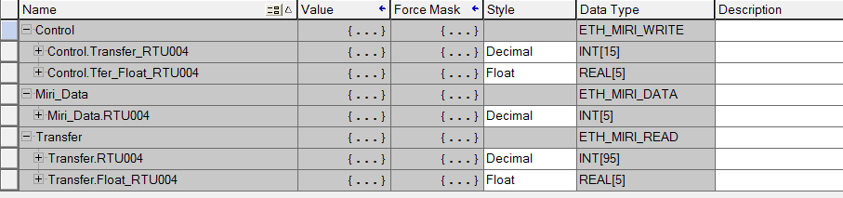
Figure 2 – Eternet/IP Controller Tag Structure
By creating the tags within the PLC controller, once the L5K is imported and the parcelling mapped from the RTU remote station to the base station the correct variable structure is maintained
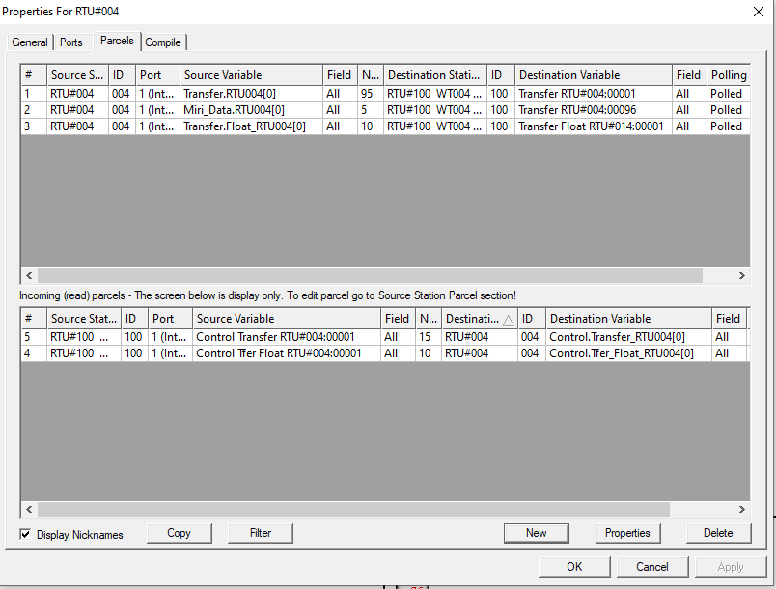
Figure 3 – Variable Mapping with Ethernet IP Integration

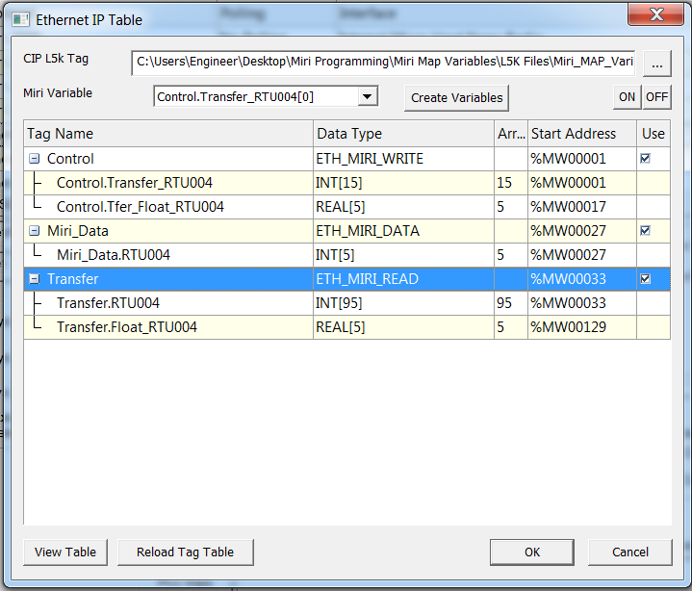
Figure 4 – Variable Mapping with Ethernet IP Integration

Base Stations and Citect Modbus Slave Stations
The variable structure of base stations shall reflect the blocks of data coming from and going to remote stations to aid tracing of data from end to end. The internal physical addresses shall be offset in the map so that they match the Modbus variable address notation used in CitectSCADA. For example, Miri physical address %MW40001 shall map to CitectSCADA Modbus address 40001.
Variable Name | Address | Function
User defined | %MW00000-499 | Internal use as required
PORT1_LNK_STS00001-10 | %MW00500-509 | Copy of internal words Link Health Port 1 Station 1-16
SCADA_READ_LNK_STS00001-10 | %MW40001-10 | Copy of PORT1_LNK_STS00001-10 to CitectSCADA mapped addresses
SCADA_READ_PLC_LNK_STS00001-10 | %MW40011-15 | PLC watchdog bits to CitectSCADA mapped addresses
User defined | %MW40016-499 | Base station internal data for CitectSCADA
As per station Variable names eg.  Transfer RTU#<Station ID>:00001-100 | %MW40500-49999 | Data from remote stations for CitectSCADA or CitectSCADA control
Table 4 – Base Stations and Citect Modbus Slave Stations data structure

Parcels
Parcels shall be used for data transfer between RTUs only. Exception shall be given for RTU internal data copying that cannot be achieved using ladder logic. For transferring data internally the ‘Data Transfer’ ladder logic routine shall be used, as per Section 5.5.9.
A typical data transfer between Remote and Base stations shall comprise four parcels:
- Station->Base Integers
- Station->Base Floats
- Base->Station Integers
- Base->Station Floats

Remote Station to Remote Station Data Transfers
In cases where data is required to be transferred from one remote station to another, the ‘Data Transfer’ routine in the base station (refer to Section 5.5.9) shall be used. Refer to Figure 5. Words for Data Transfer logic shall be located in the ‘internal words’ memory block as per Figure 1.
Station A
‘Transfer’
‘Control Transfer’
Station B
‘Transfer’
‘Control Transfer’
Station A data block
Station B data block
Base Station
Internal words
‘Data Transfer’ routine
Figure 5 – Remote Station to Remote Station Data Transfers
Although Parcels may be configured for direct transfer between remote stations, the intention of using the base station logic is to reduce the overall number of parcels configured to aid data tracing. Additionally, to aid data tracing, all data transfers are contained in a single location – the ‘Data Transfer’ routine. The transfer logic shall use word addresses in the Base Station assigned for internal use as per Figure 1.

Control of Equipment
With the exception of RTU only sites, all control logic shall be performed in the PLC where the RTU will only perform telemetry data transfer functions. Other arrangements shall require SCADA personnel approval.

Ladder Logic
The ‘Ladder Main’ routine is created by default when the station is created and should contain all JSR instructions and any global functions in the code. User defined routines shall include
- ‘Data Transfer’ for internal copying of data
- ‘RSSI and Temp’ for calculating values for CitectSCADA indication
- ‘PLC Link Status’ (Base Station only) for Remote Station PLC watchdog
Any additional routines shall be segmented into different functions and named accordingly. All ladder logic shall be arranged in a logical and user-friendly manner. All ladder logic shall be commented to assist with understanding of the function and assist with fault finding. The comment field for all variables shall be used to provide the user with additional information on the variable type and scope.

RSSI Calculation
Each remote station shall send an RSSI value to the master station and onto CitectSCADA. The RSSI shall be a scaled and averaged value of the raw measurement by the RTU. CLIENT shall issue standard logic for this operation.

Analogue Scaling
Scaling of values shall be performed in the attached PLC only, where applicable.
Analogue values that are generated from a physical connection to the RTU that require scaling may be scaled in via RTU ladder logic or in CitectSCADA.

Housekeeping
All unused variables and logic must be removed from the code before final implementation.

Citect Modbus Salve Stations
These stations shall obtain data for CitectSCADA from the Base station in a single parcel. For example, with reference to Figure 1, a single parcel would send the CitectSCADA mapped block from the Base station to the Citect Modbus Salve station. The Citect Modbus Salve physical addresses shall be offset in the map so that they match the Modbus variable address notation used in CitectSCADA.

Time Synchronisation
CitectSCADA shall write time to the default RTU time registers in the master/base RTU. The master RTU will then send the time to remote station RTUs by default. Each remote station shall in turn write time data to the local PLC.

Communication Configuration
Communications standards within the Miri network are listed as follows. Deviation from these communication configurations shall require written approval from SCADA personnel.

RTU to RTU
RTUs communicate via the Miri proprietary protocol for radio communications on Port 1. Internal Miri M series radios are used. Settings are as follows.
- Interface: Internal M-Series Radio
- Protocol: AD2000
- Polling: Master station = continuous, remote station = no polling
Transmit and receive frequencies as well as transmit power shall suit the existing network and/or comply to the ACMA license for the network. The Base Station transmit frequency shall be set to the high licensed frequency unless stated otherwise by the license.
Disabling of polling of remote stations by the master shall be achieved only within the Mirimap software by setting bit values (not by writing settings from CitecSCADA).

RTU to PLC
The preferred method of communications is Ethernet.

Ethernet
Miri AD2006+ RTUs have an Ethernet Multisession feature that allows communications via the Allen Bradley Ethernet/IP protocol. Ethernet communications shall be configured on RTU port 5. The configuration of Ethernet ports and data transfer logic shall follow the Miri Technologies document AD2006+ EtherNetIP Driver Guide.
RTU settings:
- The Lantronix Ethernet module must be firmware upgraded via DeviceInstaller as per manufacturer’s guidelines. The IP address must only be set via the MiriMap, not via DeviceInstaller.
- Interface: Ethernet
- Protocol: Ethernet/IP
- Link Failure Timeout: 1 minute
- IP address: as issued by CLIENT
The MiriMap configuration software will automatically create three multisession entries.
RSLogix5000 platform settings:
- IP address: as issued by CLIENT
- IO Configuration: Add generic Ethernet module
- Message instruction type: CIP Data Table Read/Write
- Logic: CLIENT shall issue standard templates based on manufacturers guidelines
- Arrays shall be named ‘RTU_Read’ and ‘RTU_Write’

Serial
Where the PLC does not support Ethernet or the installation is a legacy type, communications between the RTU and PLC shall use the Allen Bradley DF1 protocol.
RTU settings:
- Interface: RS232
- Protocol: Allen Bradley DF1
- Polling: Continuous (the RTU is the DF1 master that polls the PLC DF1 slave)
- PLC Subtype: AB SLC5
- PLC/Comms Unit Address: match to PLC configuration
RSLogix500 platform settings:
- Driver: DF1 Half Duplex Slave
- Node address: programmer selected (RTU configuration must match)
RSLogix5000 platform settings:
- SLC Mapping: Configure N100/N101 address mapping via Logic>Map PLC/SLC Messages
- Protocol: DF1 Slave
- Station address: programmer selected (RTU configuration must match)
The PLC address range for data written by or read from the RTU shall be:
- N100 – To RTU
- N101 – From RTU

RTU to CitectSCADA
CitectSCADA uses Modubus TCP over Ethernet to read data from the Miri RTUs. CitectSCADA acts as the Modbus TCP master polling the Miri RTU slave. The RTUs Ethernet port shall be Port 5 with settings as follows:
- Protocol: Modbus
- Interfafce: Ethernet
- Polling: no poll
- Data type: RTU
- IP settings: As per CLIENT IP address allocation, TCP port 502
Additionally, all SCADA WAN connected RTUs shall have Ethernet Multisession configured for Port 6 to allow remote access to the Miri network. Settings shall be as follows:
- Protocol: AD2006
- Polling: no poll
- IP settings: As per CLIENT IP address allocation, TCP port 10001

RTU to RTU Communications Watchdog
By default, the Miri Master RTU monitors the radio link of each remote station and stores status in internal registers. This data shall be used to display the Miri communications status on CitectSCADA for each remote station with description ‘Miri Link Status’.

PLC to RTU Communications Watchdog
For PLC devices connected to the remote stations there shall be a monitoring bit sent from the Master RTU, via remote RTU, to the PLC then back to the master RTU to monitor end-to-end communications. Standard ladder logic for the master RTU shall be issued by CLIENT. The functionality of the communications watchdog is as follows:
        - The master RTU sends a monitoring bit to the remote station
        - The remote station RTU sends the monitoring bit to the PLC
        - The PLC inverts the received monitoring bit and sends a result bit to the remote station RTU
        - The remote station RTU sends the result bit to the master RTU
        - The master RTU compares the monitoring bit to the result bit. If they are equal for more than 5 minutes the status bit is set to 1=alarm.
This data shall be used to display the PLC communications status on CitectSCADA for each remote station with description ‘PLC Link Status’.

CitectSCADA to Modbus Slave RTU Watchdog
Each primary CitectSCADA server runs Cicode via a Report to monitor the communications status of each Modbus slave RTU. Any new Modbus slave RTU installation shall have the necessary logic to for comms checking and shall be added to the Cicode script. See D2017/203322 Client- SCADA Standards - Volume 2-01 – CitectSCADA for a detailed description of the communication monitoring Cicode.
This data shall be used to display the communications status on CitectSCADA on the communications monitoring pages.

Store and Forward Stations
The implementation of Store and Forward stations with the Miri network shall consider ACMA licensing requirements for re-transmission of base station signals. There are no specific configuration requirements for store and forward stations as the functionality is established in the MiriMap by the creation of network links.

Small Scale RTU Systems
Services SCADA provides for an RTU system for small monitoring sites with reduced cost compared to Ethernet radio and Miri RTU schemes. Small Scale RTU systems comprise a compact, IP68 telemetry unit, with a small number of digital and analog inputs. Communication is via the cellular phone network. Additionally, the units may be powered by batteries (for very low demand instrumentation measurement) or a battery/solar system.
A small scale RTU system is suited to simple applications including:
- Single instrument monitoring site
- Limited access to existing Services operated telemetry network
- Limited power supply availability
- Small footprint
- Restrictions on telemetry antenna installation

RTU Data Link Architecture
Data from small scale RTUs in the field is in 16 bit integer with timestamp format, and is aggregated in a ClearSCADA server, bhsvr05, installed at the CLIENT Ben Hammond Facility. ClearSCADA is configured as the DNP3 master to listen for unsolicited messages from RTUs via the DNP3 protocol. The CLIENT Data Historian reads data from the ClearSCADA server for display to operations personnel.

Communications
Small scale RTUs use DNP3 over IP to communicate to the ClearSCADA servers. The link is provided by the Telstra 3G cellular network, for which Services has a Private Mobile Network (APN) to provide secure communications. Services shall provide SIM cards, activated with the APN, for installation into RTUs.
RTUs shall use an unsolicited communications methodology, whereby the RTU contacts the ClearSCADA server with logged data on a scheduled basis or on exception. Messaging on exception may be triggered by a local alarm state or threshold values, and shall be identified in the plant or project functional specification.
A communications test report was documented in the development stages of the small scale RTU system - PSC Cellular RTU Communication Test Report D2018/100471.

Limitations on RTU data into Citect
At the time of writing, data from small scale RTU systems is not able to be provided for operator feedback on CitectSCADA. The RTU data is only able to be viewed and manipulated via the CLIENT Data Historian.

RTU Hardware Selection
Services uses Metasphere Point Orange RTU units as per the Approved Hardware and Software SCADA Standard.
Small scale RTU systems should generally not be installed into established sites or facilities, alongside existing RTU systems such as Ethernet radio or Miri RTUs. Established site RTU systems shall have their existing configurations augmented with whatever additional functionality is required.

Software Version
Refer to the Approved Hardware and Software SCADA Standard for ClearSCADA and RTU configuration software versions.

ClearSCADA Configuration
Services SCADA shall supply a template RTU object with basic settings for a Metasphere Point Orange RTU site. Customisation of the template to suit the application shall include IP address, DNP3 address and required measurement points (analog or digital inputs). DNP3 addresses shall be applied in the following ranges, and shall be issued by SCADA personnel:
- 0-1000 = Master stations/Hosts with ClearSCADA = 1
- 1000 onwards = Remote Devices

Naming
Each RTU object in ClearSCADA shall be named according to the Site Identifier for the monitoring site. Standalone monitoring Site Identifiers are typically of the form WMZNNN. Refer to the Tag Naming Convention SCADA Standard D2017/203340 for more information.
Naming in the RTU configuration file shall be as follows:
- Device ID: Site Identifier
- Device Name: Common operational name (typically region and/or monitoring function)
- Device location: Street address

RTU Configuration
The following sections are arranged as per the RTU configuration software tabs, and the parameters listed shall be set as standard. Some of these parameters will already be set in the RTU configuration template issued by SCADA personnel.

DNP3
- Source ID: DNP3 Remote Device address
- Destination ID: 1 (ClearSCADA master address)

Comms
- Communicate Every: As per functional specification
- Media: GPRS/3G

APN Settings
SCADA personnel shall issue unique APN credentials (username and password) for each RTU installation. A unique username and password shall be issued for each RTU installation. The following communications settings shall apply:
- APN Name: water.powerwater.com.au
- APN Username: rtuNN, where NN shall be issued by SCADA personnel
- ANP Password: shall be issued by SCADA personnel
- Authentication: PAP

I/O
IO shall be added as per the functional specification.

Groups
The Analog Input group shall be configured as listed below. Other groups shall be configured on a case by case basis as per the requirements of the functional specification.
- Integrity Poll: Checked (default)
- Default Variation: Analog Input (30), single-precision, floating-point with flag (5)
- Default Event Variation: Analog input change event (32), 16 bit with time (4)
- Default Event Class: Class 1
- Max Events: 0

Points
Figure 6 and Figure 7 show a standard configuration for a single analog input (AI0) pressure transmitter installation. Some variation on this example shall be required for different instrumentation or more complex applications with multiple IO, which shall be described in the functional specification.

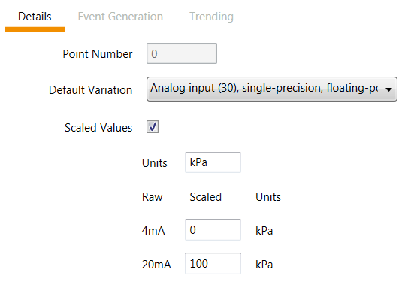
Figure 6 – Metasphere Point Orange Point Details configuration example

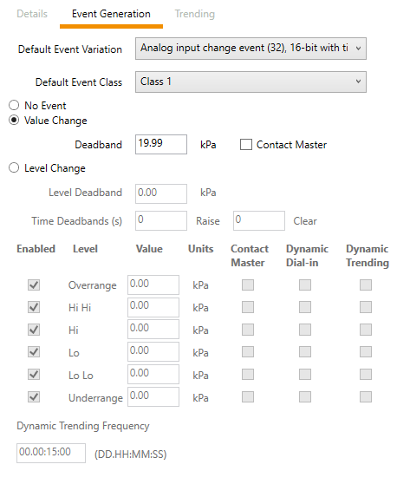
Figure 7 – Metasphere Point Orange Event Generation configuration example

Installations for Intermittent Monitoring
Where a process variable in the field requires only intermittent monitoring, a standalone, battery powered RTU may be installed. Applications may include level switches or other digital signals where the change in signal triggers the RTU to ‘wake up’, log the data and report it to the ClearSCADA server on an infrequent basis.
The field installation need only comprise of the RTU unit, instrument, appropriate mounting systems for RTU and instrument, and appropriate mounting system for an external antenna.
This type of configuration may also apply where the instrumentation being used is very low power, required measurement resolution is low, the RTU is only required to update the ClearSCADA server one or two times per day.

Installations for Continuous Monitoring
Typical 4-20mA instrumentation power demand will be too much for RTU internal batteries to maintain, therefore these installations shall require a battery/solar supply or mains supply. Very low power instrumentation may be considered for RTU systems with battery only, but approval shall be obtained from SCADA personnel and the instrumentation coordinator prior to implementation.
The RTU, instrument and auxiliary equipment shall be installed in a lockable cabinet. Antennas and solar panels will be mounted securely with consideration to damage from vandalism.

File Storage
RTU configuration files shall be stored in the designated CLIENT software repository.
The file name shall be in the format:
<Site Identifier>_<yyyymmdd>

Installation
This section primarily relates to Ethernet radio and Miri RTU installations

Antenna Selection
Antennas shall be selected according to Preferred Equipment List SCADA Standard, and shall comply with limitations prescribed by the radio spectrum license.
Base Station units shall use a dipole array antenna and Remote Station units shall use a Yagi. Point to point links shall use a Yagi antenna at both ends.

Antenna Installation
Antenna equipment shall be installed in such a way that it shall be free from obstructions and shall be secured against excessive movement from wind and vibration.
Where sites require a purpose built radio tower (not including pre-manufacture masts), a set of engineer approved detailed design drawings (including wind loading verification report) shall be provided to Services for approval. It shall be the responsibility of the installer to ensure the structure is certified compliant by the relevant engineering bodies.
Dipole array Omni-directional antennas may require some alignment due to the non-uniform gain profile.
Yagi and Parabolic antennas shall be aligned so to be within tolerance of plus or minus 2 degrees in the horizontal plane.

Coaxial Cable
Coaxial cable, provided for interconnection between transmitters and antennas, shall be selected so to ensure installed cable signal attenuation is kept to a minimum value.
The installer shall use Table 5 to choose the appropriate medium and the final installed product shall exhibit equal or better physical, electrical and loss characteristics.
Equivalent products can be used where they exhibit equal or better physical and electrical characteristics.

Cable Type | Part Number | 400-520MHz
CELLFOAM | 9001 | 9.8dB
CELLFOIL | 9006 | 6.9dB
RG213/U | 8213 | 5.0dB
RG214/U | 8214 | 5.0dB
10D-FB | 9005 | 2.4dB
RG8 | CNT-400 | 3.1dB
3/8” Superflex | FSJ2-50 | 2.8dB
½” Superflex | FSJ4-50 | 2.4dB
½” Heliax | LDF4-50 | 1.6dB
Table 5 – Coaxial Cable Selection

Cable Runs and Connectors
Coaxial cable runs interconnecting devices shall be completed in a continuous run. No joins shall be permitted for permanent installations. Coaxial connectors shall be installed as prescribed by the manufacturer and be fit for purpose.

Cable Support
Cable shall be supported in its entirety utilizing any or all of the following techniques:
- Enclosed in PVC conduit.
- Secured to cable trays with cable ties.
- Secured to mast structures with cable ties.
- Cable clips
Coaxial cable shall only be secured to metal or plastic pipework with nylon ties when it forms part of a masting structure.

Cable Protection
Cables may be enclosed in steel conduit where deemed necessary to protect against vibration or animal damage.

Moisture Ingress
Cable connectors which are installed in locations exposed to the elements shall be completely sealed using a self-amalgamating tape (such as 3M Scotch 23). These are to then be covered in black PVC electrical tape.

Surge Protection
All antenna equipment which is mounted externally to a building will be fitted with lightning surge arrestor protection at the transmitter end. All surge arrestor equipment is to be designed for operation in the frequency range of the transmitting equipment. Refer to the Preferred Equipment List SCADA Standard for approved surge arrestors.

Coaxial Earthing
Coaxial Cable outer shields are to be bonded to earth prior to the cable leaving the tower structure using fit for purpose earthing kits.

RF Filters
Radio equipment operating in a full-duplex mode or installed at a site with other RF emitters (‘high site’), shall be supplemented with filtering equipment to reduce interference. Filters shall represent no more than a 1.75dB insertion loss to the system

Power Supplies
Approved RTUs and radio units will operate with a power supply range of 0-30V.
Telemetry equipment shall typically be installed with other Services electrical equipment with UPS extra low voltage supply. In cases where the RTU or radio unit is standalone, the plant functional specification shall identify critical communications and specify whether power supply redundancy is required.

Installations in Communications Cabinets
Refer to the IP Networks and Communication Installations SCADA Standard.

Change Management
SCADA personnel approval is required before any configuration changes are made to an telemetry system, except in after-hours call-out or emergency situations. A risk assessment, notification and approval process shall be followed before telemetry system changes.

Version Control
Configuration files will be checked in and checked out of the Water Service SCADA file repository by SCADA personnel only, following approval of works.
At the time of check-in or check-out, this activity will be recorded including the current location and holder of the file, and summary details of the change.
File names in the repository shall be as per Section 4.5 and Section 5.5.1.
SCADA personnel shall review all telemetry changes or deployments upon check-in.

Documentation
The following documentation shall be maintained in the EDMS:
- RTU mapping records
- Network drawings
- Google Earth radio link file
- Services SCADA IP Address Register
- Equipment registers
- Network design plans and procedures
- Telemetry site commissioning records

References

Legislation and Regulatory Obligations
In addition to this document all work shall be carried out in accordance with the relevant Australian Standards. The standards and guidelines in Table 6 may also be applied where practical.
Reference number | Title
AS 4418 | Supervisory Control and Data Acquisition (SCADA)
ISA 95 | Enterprise – Control System Integration
800-20 NIST | Guide to ICS Security
AS/CA S009 | Installation Requirements for Customer Cabling (Wiring Rules)
AS/NZS 3080 | Telecommunications installations – Generic cabling for commercial premises
AS/NZS 3084 | Telecommunications installations - Telecommunications pathways and spaces for commercial buildings
ISO/IEC 14763-2 | Information technology -- Implementation and operation of customer premises cabling -- Part 2: Planning and installation
AS/NZS HB29 | Communications Cabling Manual Module 2: Communications cabling handbook
ANSI/EIA 568 | Commercial Building Telecommunications Cabling Standards
AS/NZS 1768 | Lightning Protection
Table 6 - Referenced Standards

CLIENT Water Service SCADA Standards
This document shall be read in conjunction with all documents contained in the Client SCADA Standards package.

Definitions
Term/Acronym | Definition
ACMA | Australian Communications and Media Authority
AD | Windows Active Directory
AIO | Add on Instruction (Allen Bradley PLC programming software)
CA | Citect Anywhere
Control systems | Localised systems for control of individual sites/facilities
DMZ | Demilitarised Zone
EDMS | CLIENT Electronic Document Management System (RM8, Maximo)
FAT | Factory Acceptance Testing
FBD | Function Block Diagram (Allen Bradley PLC programming software)
FS | Functional Specification
HMI | Human-Machine-Interface
I/O | Input / Output
IP | Internet Protocol
IP/MPLS | Asynchronous IP/Multiprotocol Label Switching network
LAN | Local Area Network
LWWTP | Ludmilla Wastewater Treatment Plant
Maximo | The Power and Water Corporation asset management system
OEM | Original Equipment Manufacturer
Operations/Operations Personnel | The business group/personnel who operate and supervise water and wastewater plant and processes. Includes field operation personnel, their supervisors, coordinators and managers
OTDR | Optical Time-Domain Reflectometer
P&ID | Piping and instrumentation diagram/drawing
PC | Personal computer devices. Shall include desktop computers, laptop computers, tablets and miniature computers.
PDH | Plesiochronous Digital Hierarchy (telecommunications)
PLC | Programmable Logic Controller
CLIENT | Power and Water Corporation
RADIUS | Remote Authentication Dial-in User Service
RDS/RDP | Windows Remote Desktop Services
RF | Radio Frequency
RSSI | Relative received signal strength in a wireless environment
RTU | Remote Telemetry Unit
SAT | Site Acceptance Testing
SCADA | Supervisory Control and Data Acquisition
SCADA Network/WAN | Network of all SCADA system devices bounded by the interface to Data Historian and Corporate networks
SCADA Personnel | Personnel within the Services SCADA and Instrumentation Group
SDH | Synchronous Digital Hierarchy (telecommunications)
Segmentation | Separation of Ethernet network into subnets
Segregation | Separation of Ethernet network by physical barriers (e.g. PLC backplane)
SMS | Telco provided Short Message Service
SNTP | Simple Network Time Protocol
SPS | Sewer Pump Station
UDT | User defined data type (Allen Bradley PLC programming software)
VM | Virtual Machine
VPN | Virtual Private Network
VSD | Variable Speed Drive
Water Services | The Water Service Group of the Power and Water Corporation
WS SCADA | Services SCADA system
WTP | Water Treatment Plant
WWTP | Wastewater Treatment Plant
Table 7– Definitions

Roles and Responsibilities

Document Owner
The Client SCADA Coordinator is the owner of this document.

SCADA personnel
Services SCADA Personnel are responsible for setting and maintaining standards for SCADA Systems in all Services facilities.
Any requests for variation or modification of these standards shall be submitted to the document owner and made in accordance with the approved change management process.

Contractors
Contractors shall ensure that all works undertaken comply with the relevant Australian Standards, regulatory requirements and CLIENT SCADA Standards.
Where there is a requirement to deviate from the SCADA Standards, approval in writing shall be obtained from SCADA personnel before any work commences.

Records
This document is maintained in the CLIENT Electronic Document Management System.

Review
This standard will be reviewed every three (3) years or in the event of any significant changes in systems or processes.

